Copilot (ChatGPT after)
Absolutely — let’s build two upgraded diagrams:
- A cleaner, more visual ASCII ERD (optimized for Word, GitHub, or plain-text documentation)
- A color-coded version designed specifically for PowerPoint, using text-based color cues that translate well into slide formatting
No images are generated — everything is text-based and ready to paste into your slides.
1. CLEAN, VISUAL ASCII DIAGRAM (ERD-STYLE)
This version emphasizes hierarchy, alignment, and clarity.
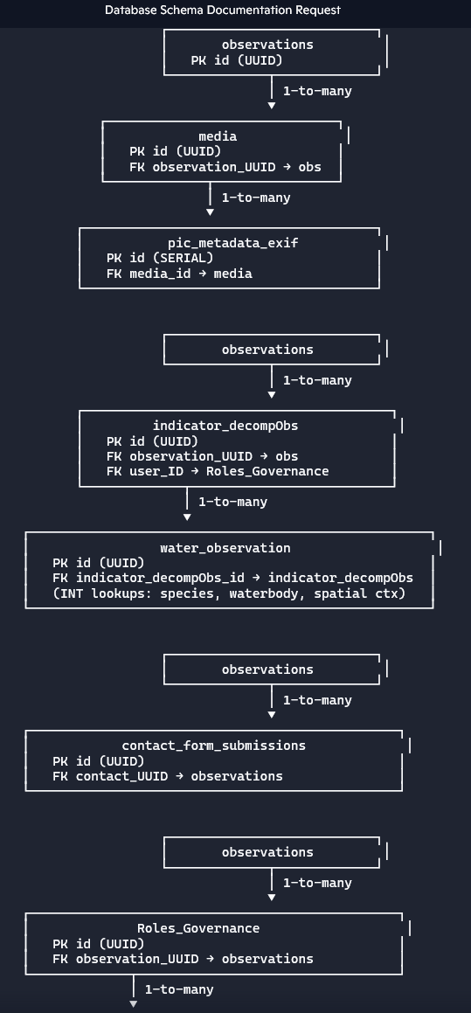

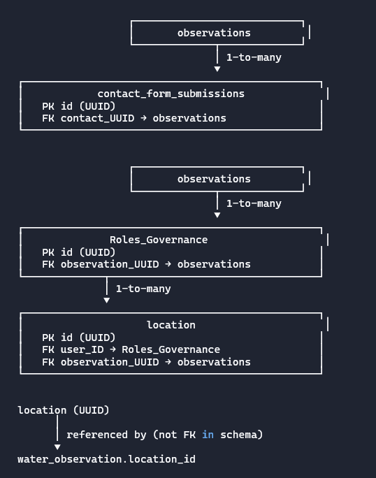

┌───────────────────────────┐ │ observations │ │ PK id (UUID) │ └─────────────┬─────────────┘ │ 1-to-many ▼ ┌──────────────────────────────┐ │ media │ │ PK id (UUID) │ │ FK observation_UUID → obs │ └─────────────┬────────────────┘ │ 1-to-many ▼ ┌──────────────────────────────────────┐ │ pic_metadata_exif │ │ PK id (SERIAL) │ │ FK media_id → media │ └──────────────────────────────────────┘ ┌───────────────────────────┐ │ observations │ └─────────────┬─────────────┘ │ 1-to-many ▼ ┌────────────────────────────────────────┐ │ indicator_decompObs │ │ PK id (UUID) │ │ FK observation_UUID → obs │ │ FK user_ID → Roles_Governance │ └─────────────┬──────────────────────────┘ │ 1-to-many ▼ ┌────────────────────────────────────────────────────┐ │ water_observation │ │ PK id (UUID) │ │ FK indicator_decompObs_id → indicator_decompObs │ │ (INT lookups: species, waterbody, spatial ctx) │ └────────────────────────────────────────────────────┘ ┌───────────────────────────┐ │ observations │ └─────────────┬─────────────┘ │ 1-to-many ▼ ┌────────────────────────────────────────────────┐ │ contact_form_submissions │ │ PK id (UUID) │ │ FK contact_UUID → observations │ └────────────────────────────────────────────────┘ ┌───────────────────────────┐ │ observations │ └─────────────┬─────────────┘ │ 1-to-many ▼ ┌────────────────────────────────────────────────┐ │ Roles_Governance │ │ PK id (UUID) │ │ FK observation_UUID → observations │ └─────────────┬──────────────────────────────────┘ │ 1-to-many ▼ ┌────────────────────────────────────────────────┐ │ location │ │ PK id (UUID) │ │ FK user_ID → Roles_Governance │ │ FK observation_UUID → observations │ └────────────────────────────────────────────────┘ location (UUID) │ │ referenced by (not FK in schema) ▼ water_observation.location_id
2. COLOR-CODED VERSION FOR POWERPOINT (TEXT-BASED)
Use this in PowerPoint by applying colors to each block:
Recommended color palette (nature/water theme):
- Blue (#1F77B4) → Water-related tables
- Green (#2CA02C) → Ecological / indicator tables
- Brown (#8C564B) → Metadata / EXIF
- Teal (#17BECF) → Governance / user roles
- Gray (#7F7F7F) → Utility / contact forms
- Dark Blue (#1A4E8A) → Core observations table
Below is the diagram with color tags you can apply in PowerPoint.
COLOR-CODED POWERPOINT DIAGRAM (PASTE INTO SLIDES)
[Dark Blue] observations (PK id UUID) │ ├──────────────► [Blue] media (FK observation_UUID) │ │ │ └────────► [Brown] pic_metadata_exif (FK media_id) │ ├──────────────► [Green] indicator_decompObs (FK observation_UUID) │ │ │ └────────► [Green] water_observation │ (FK indicator_decompObs_id) │ (INT lookups: species, waterbody, spatial ctx) │ ├──────────────► [Gray] contact_form_submissions (FK contact_UUID) │ └──────────────► [Teal] Roles_Governance (FK observation_UUID) │ └────────► [Teal/Green] location (FK user_ID, FK observation_UUID) referenced by water_observation.location_id

Want an even more polished version?
I can also generate:
- A slide-ready two-column layout
- A “swimlane” style diagram
- A hierarchical tree
- A color-coded legend
- A Phase 2 expanded ERD
Just tell me the style you want to use in your deck.

I. FULL DATA DICTIONARY TABLE (LANDSCAPE, AUTOFIT, W1 + T1 + C2)
Columns:
Table Name | Attribute | Attribute Type | 1–5 Word Description | Notes | Key
Tip for Word: After pasting, select the table → Layout → AutoFit → AutoFit to Contents.

TABLE: observations
Table Name | Attribute | Attribute Type | Description | Notes | Key
observations | id | UUID (observation_UUID) | primary key | generated UUID | PK
observations | submitted_at | TIMESTAMPTZ | submission time | auto timestamp
observations | observed_at | TIMESTAMPTZ | observation time
observations | data_source | ENUM (observation source) | source type | user/sensor/3rd party
observations | user_UUID | TEXT | user identifier | no FK defined
observations | tags_user_device | TEXT[] | device/user tags | array of tags
observations | tags_AI_ConfidL | ENUM (AI confidence level) | AI confidence | inferred type
observations | tags_AI_Option1 | TEXT | AI tag option 1
observations | tags_AI_Option2 | TEXT | AI tag option 2
observations | tags_AI_Option3 | TEXT | AI tag option 3
observations | tag_user_Selected1 | TEXT | user-selected tag
observations | tag_user_Selected1_ConfidL | ENUM (user tag confidence) | confidence level
observations | validation_status | ENUM (validation status) | validation state | pending/validated/rejected
observations | validation_reject | ENUM (reject reason) | rejection reason | updated/awaiting/unidentifiable
observations | is_deleted | BOOLEAN | soft delete flag | soft delete

TABLE: media
Table Name | Attribute | Attribute Type | Description | Notes | Key
media | id | UUID (media_UUID) | primary key | generated UUID | PK
media | observation_UUID | UUID | observation reference | FK to observations | FK
media | media_type | ENUM (media type) | type of media | image/video/audio
media | metadata_extracted | BOOLEAN | metadata extracted | yes/no
media | storage_url | TEXT | storage location | cloud or cache

TABLE: pic_metadata_exif
Table Name | Attribute | Attribute Type | Description | Notes | Key
pic_metadata_exif | id | SERIAL | primary key | auto-increment | PK
pic_metadata_exif | media_id | UUID | media reference | FK to media | FK
pic_metadata_exif | camera_make | TEXT | camera make
pic_metadata_exif | camera_model | TEXT | camera model
pic_metadata_exif | datetime_original | TIMESTAMP | original timestamp | EXIF
pic_metadata_exif | altitude | DOUBLE PRECISION | altitude | EXIF
pic_metadata_exif | orientation | TEXT | orientation | EXIF
pic_metadata_exif | exposure_time | TEXT | exposure | EXIF
pic_metadata_exif | f_number | TEXT | aperture | EXIF
pic_metadata_exif | iso | INTEGER | ISO value | EXIF
pic_metadata_exif | focal_length | TEXT | focal length | EXIF
pic_metadata_exif | flash | TEXT | flash info | EXIF
pic_metadata_exif | additional_metadata | JSONB | extra metadata | EXIF JSON

TABLE: indicator_decompObs
Table Name | Attribute | Attribute Type | Description | Notes | Key
indicator_decompObs | id | UUID (indicator_UUID) | primary key | generated UUID | PK
indicator_decompObs | observation_UUID | UUID | observation reference | FK to observations | FK
indicator_decompObs | user_ID | UUID | user reference | FK to Roles_Governance | FK
indicator_decompObs | indicator_type | ENUM (indicator type) | indicator category | water/plant/animal
indicator_decompObs | indicator_name | TEXT | indicator name | species/waterflow/etc
indicator_decompObs | severity_level | ENUM (severity level) | severity | low/med/high

TABLE: contact_form_submissions
Table Name | Attribute | Attribute Type | Description | Notes | Key
contact_form_submissions | id | UUID (user_UUID) | primary key | generated UUID | PK
contact_form_submissions | contact_UUID | UUID | observation reference | FK to observations | FK
contact_form_submissions | issue_type | TEXT (CHECK) | issue category | dropdown
contact_form_submissions | details | TEXT (≤160 chars) | issue details | character limit
contact_form_submissions | submitted_at | TIMESTAMP | submission time | auto timestamp
contact_form_submissions | name | TEXT | submitter name | required
contact_form_submissions | response_preference | TEXT (CHECK) | wants response | yes/no
contact_form_submissions | contact_method | TEXT (CHECK) | contact method | email/text/call
contact_form_submissions | contact_details | TEXT | contact info

TABLE: Roles_Governance
Table Name | Attribute | Attribute Type | Description | Notes | Key
Roles_Governance | id | UUID (user_UUID) | primary key | generated UUID | PK
Roles_Governance | observation_UUID | UUID | observation reference | FK to observations | FK
Roles_Governance | user_role | ENUM (user role) | governance role | admin/public/reviewer
Roles_Governance | cohort | ENUM (cohort) | user cohort | testers/pilot/public
Roles_Governance | consent_version | ENUM (consent version) | consent version | v1.0/v1.1/v2.0

TABLE: location
Table Name | Attribute | Attribute Type | Description | Notes | Key
location | id | UUID (location_UUID) | primary key | generated UUID | PK
location | latitude | DOUBLE PRECISION | latitude
location | longitude | DOUBLE PRECISION | longitude
location | observation_UUID | UUID | observation reference | FK to observations | FK
location | user_ID | UUID | user reference | FK to Roles_Governance | FK
location | spatial_context | ENUM (spatial context) | GIS context | site/park/etc
location | ownership_type | ENUM (ownership type) | ownership | public/private/etc
location | land_use_primary | ENUM (primary land use) | land use | inferred
location | known_wetland | ENUM (wetland type) | wetland status | inferred
location | public_access | ENUM (public access) | access type | inferred
location | classification_source | ENUM (classification source) | data provenance | QA source

TABLE: water_observation
Table Name | Attribute | Attribute Type | Description | Notes | Key
water_observation | id | UUID (water_obs_UUID) | primary key |  | PK
water_observation | location_id | UUID | location reference | no FK defined
water_observation | waterbody_type_id | INT | waterbody type | lookup later
water_observation | spatial_context_id | INT | spatial context | lookup later
water_observation | indicator_species_id | INT | species reference | lookup later
water_observation | indicator_decompObs_id | UUID | indicator reference | FK to indicator_decompObs | FK
water_observation | species_presence | ENUM (species presence) | presence state | present/absent/etc
water_observation | flow_type | ENUM (flow type) | water flow | still/slow/fast
water_observation | water_color | ENUM (water color) | color | clear/brown/etc
water_observation | turbidity_level | ENUM (turbidity level) | turbidity | low/mod/high
water_observation | surface_conditions | SET (surface condition flags) | surface traits | foam/oil/algae/etc
water_observation | ai_confidence_score | DECIMAL(3,2) | AI confidence
water_observation | classification_source | ENUM (classification source) | data provenance | AI/user/field
water_observation | observed_at | TIMESTAMP | observation time | required

Footnote 1:
ENUM will be updated to Lookup tables in Phase 2.
Footnote 2:
Non-UUID keys:
- pic_metadata_exif.id (SERIAL)
- water_observation.waterbody_type_id (INT)
- water_observation.spatial_context_id (INT)
- water_observation.indicator_species_id (INT)

II. OUTLINE — Water Observations (Phase 1)
Purpose
- Capture AI- and user-observed ecological signals
- Use one indicator species + visual water traits
- Support early water quality inference without chemistry
- Prepare for future neural-net validation using lab samples
Scope
- Single species indicator
- Visual water characteristics (flow, color, turbidity, surface conditions)
- AI confidence + provenance metadata
- Spatial context via location table
Future Phases
- Multiple species
- Chemical sampling integration
- Neural-net training for predictive water quality
- Expanded GIS layers and zoning codes

III. SMARTART-STYLE RELATIONSHIP DIAGRAM (TEXT-BASED)
observations (PK: id)
↓ FK
media (observation_UUID)
↓ FK
pic_metadata_exif (media_id)

observations (PK: id)
↓ FK
indicator_decompObs (observation_UUID)
↓ FK
water_observation (indicator_decompObs_id)

observations (PK: id)
↓ FK
contact_form_submissions (contact_UUID)

observations (PK: id)
↓ FK
Roles_Governance (observation_UUID)
↓ FK
location (user_ID)

location (PK: id)
↓ reference (not FK in schema)
water_observation (location_id)

IV. POWERPOINT-READY CONTENT (2 SLIDES)
Slide 1 — Core Observation Flow
Title: Observation → Media → Metadata
Diagram (paste as text box):
observations (PK)
↓ FK
media (FK → observations)
↓ FK
pic_metadata_exif (FK → media)
Notes:
- Non-UUID key: pic_metadata_exif.id (SERIAL)

Slide 2 — Ecological Indicators + Water Observations
Title: Indicators + Water Traits
Diagram:
observations (PK)
↓ FK
indicator_decompObs (FK → observations)
↓ FK
water_observation (FK → indicator_decompObs)

location (PK)
↓ reference
water_observation (location_id)
Notes:
- Non-UUID keys: waterbody_type_id, spatial_context_id, indicator_species_id

ChatGPT
observations (PK: id – UUID)
├── media (FK: observation_UUID)
│ └── pic_metadata_exif (FK: media_id; PK: SERIAL)
├── indicator_decompObs (FK: observation_UUID)
└── location (FK: observation_UUID)

water_observation (PK: id – UUID)
├── FK → location.id (UUID)
├── FK → indicator_decompObs.id (UUID)
├── INT lookup: indicator_species_id
├── INT lookup: waterbody_type_id
└── INT lookup: spatial_context_id
VERSION A — GIS-FORWARD (Stakeholder-Facing)
Visual guidance (apply once)
- Background: white or very light sand / pale sky blue
- Primary color: muted teal or river blue
- Accent: soft green (wetlands / land context)
- Icons (optional): map pin, layers, river line

Slide 1 — How Observations Connect to Place
Title:
How Community Observations Connect to Place
Body (formatted text / SmartArt-ready):
Observations
(PK: Observation ID – UUID)
│
├── Media
│ (photos, video, audio)
│
├── Ecological Indicators
│ (water, plant, animal signals)
│
└── Location
(latitude, longitude, spatial context)
Callout (right or bottom, small text):
Each observation is anchored to a real place, allowing analysis across neighborhoods, parks, and waterways.
Footer note:
Primary keys use UUIDs for privacy and scalability.

Slide 2 — Water Observations: Spatial Focus (Phase 1)
Title:
Water Observations — Spatial Focus (Phase 1)
Body (formatted text):
Water Observation
(PK: Water Observation ID – UUID)
│
├── Linked Location
│ (point, corridor, neighborhood)
│
├── Indicator Species
│ (single species, Phase 1)
│
└── Visual Water Traits
(flow, color, turbidity, surface)
Callout:
Phase 1 prioritizes where potential water issues occur, enabling targeted follow-up and equitable planning.
Footer note:
Some classification fields use numeric lookups; these will be expanded in later phases.

VERSION B — AI-FORWARD (Stakeholder-Facing)
Visual guidance (apply once)
- Background: white or very light mist gray
- Primary color: soft blue / slate
- Accent: teal or cyan (technology + water)
- Icons (optional): camera, sparkle/AI node, checkmark

Slide 1 — From Observation to Insight
Title:
From Observation to Insight
Body (formatted text / SmartArt-ready):
Observations
(PK: Observation ID – UUID)
│
├── Media Inputs
│ (images, video, audio)
│
├── AI & User Tags
│ (with confidence levels)
│
└── Validation Status
(pending, reviewed, updated)
Callout:
The system combines community input and AI assistance while keeping humans in the loop.
Footer note:
Unique identifiers protect user privacy and support reliable analytics.

Slide 2 — Water Observations: AI-Assisted Signals (Phase 1)
Title:
Water Observations — AI-Assisted Signals (Phase 1)
Body (formatted text):
Water Observation
(PK: Water Observation ID – UUID)
│
├── Indicator Species
│ (presence / absence / uncertain)
│
├── Visual Water Signals
│ (flow, color, turbidity, surface)
│
└── Confidence & Source
(AI-derived, user-reported, verified)
Callout:
These early signals help identify water bodies that may need further testing or intervention.
Footer note:
Chemical testing and model training occur in later phases.

How to use both versions strategically
- GIS-forward → planners, conservation orgs, municipalities
- AI-forward → funders, innovation partners, technical reviewers
- Keep both in the same deck appendix if needed — they reinforce each other without conflict.
When the download tool is available again, I can:
- Generate light-background PNGs for all 4 slides
- Package both versions into one PPTX with clear section labels
If you want, next we can also create a single hybrid slide that visually bridges GIS + AI for executive audiences.

ChatGPT can make mistakes. Check important in

Phase 1 Database Data Dictionary (Grouped by Table)
Table | Attribute | Type | Description | Notes | Key
observations | id | UUID | Observation identifier | auto-generated | PK
observations | submitted_at | TIMESTAMPTZ | Submission time | system default
observations | observed_at | TIMESTAMPTZ | Observed time | user or sensor
observations | data_source | ENUM | Source type | Phase 1 ENUM
observations | user_UUID | TEXT | Submitting user | external auth
observations | tags_user_device | TEXT[] | Device/user tags | raw input
observations | tags_AI_ConfidL | ENUM | AI tag confidence | Phase 1 ENUM
observations | tag_OptionONLY_P1 | TEXT | Primary AI tag | single tag
observations | tags_AI_Option1 | TEXT | AI alt tag 1 | optional
observations | tags_AI_Option2 | TEXT | AI alt tag 2 | optional
observations | tags_AI_Option3 | TEXT | AI alt tag 3 | optional
observations | tag_user_Selected1 | TEXT | User-selected tag | single only
observations | tag_user_Selected1_ConfidL | ENUM | User tag confidence | Phase 1 ENUM
observations | validation_status | ENUM | Validation state | workflow
observations | validation_reject | ENUM | Rejection reason | if rejected
observations | is_deleted | BOOLEAN | Soft delete flag | logical delete
media | id | UUID | Media identifier | auto-generated | PK
media | observation_UUID | UUID | Observation link | parent record | FK
media | media_type | ENUM | Media format | image/video/audio
media | metadata_extracted | BOOLEAN | EXIF extracted | processing flag
media | storage_url | TEXT | Storage location | cloud/cache
pic_metadata_exif | id | SERIAL | EXIF record ID | non-UUID | PK
pic_metadata_exif | media_id | UUID | Media link | cascade delete | FK
pic_metadata_exif | camera_make | TEXT | Camera make | EXIF
pic_metadata_exif | camera_model | TEXT | Camera model | EXIF
pic_metadata_exif | datetime_original | TIMESTAMP | Capture time | EXIF
pic_metadata_exif | altitude | DOUBLE | Altitude | GPS EXIF
pic_metadata_exif | orientation | TEXT | Image orientation | EXIF
pic_metadata_exif | exposure_time | TEXT | Exposure time | EXIF
pic_metadata_exif | f_number | TEXT | Aperture | EXIF
pic_metadata_exif | iso | INTEGER | ISO speed | EXIF
pic_metadata_exif | focal_length | TEXT | Focal length | EXIF
pic_metadata_exif | flash | TEXT | Flash info | EXIF
pic_metadata_exif | additional_metadata | JSONB | Other EXIF data | flex field
indicator_decompObs | id | UUID | Indicator ID | auto-generated | PK
indicator_decompObs | observation_UUID | UUID | Observation link | parent | FK
indicator_decompObs | user_ID | UUID | Submitting user | governance | FK
indicator_decompObs | indicator_type | ENUM | Indicator category | water/plant/etc
indicator_decompObs | indicator_name | TEXT | Indicator name | free text
indicator_decompObs | severity_level | ENUM | Severity level | low-high
Roles_Governance | id | UUID | User ID | auto-generated | PK
Roles_Governance | observation_UUID | UUID | Observation link | context | FK
Roles_Governance | user_role | ENUM | Role type | access control
Roles_Governance | cohort | ENUM | User cohort | rollout
Roles_Governance | consent_version | ENUM | Consent version | legal
location | id | UUID | Location ID | auto-generated | PK
location | latitude | DOUBLE | Latitude | WGS84
location | longitude | DOUBLE | Longitude | WGS84
location | observation_UUID | UUID | Observation link | context | FK
location | user_ID | UUID | Submitting user | governance | FK
location | spatial_context | ENUM | Spatial scale | GIS derived
location | ownership_type | ENUM | Ownership | GIS overlay
location | land_use_primary | ENUM | Land use | GIS overlay
location | known_wetland | ENUM | Wetland status | designation
location | public_access | ENUM | Access type | equity
location | classification_source | ENUM | Source provenance | QA
water_observation | id | UUID | Water observation ID | manual PK | PK
water_observation | location_id | UUID | Location link | required | FK
water_observation | waterbody_type_id | INT | Waterbody type | lookup
water_observation | spatial_context_id | INT | Spatial context | lookup
water_observation | indicator_species_id | INT | Species ID | lookup
water_observation | indicator_decompObs_id | UUID | Indicator link | parent | FK
water_observation | species_presence | ENUM | Species presence | visual
water_observation | flow_type | ENUM | Flow state | visual
water_observation | water_color | ENUM | Color | visual
water_observation | turbidity_level | ENUM | Turbidity | visual
water_observation | surface_conditions | SET | Surface traits | visual
water_observation | ai_confidence_score | DECIMAL | AI confidence | 0–1
water_observation | classification_source | ENUM | Data source | AI/user
water_observation | observed_at | TIMESTAMP | Observed time | required
Footnote: ENUM fields will be refactored into Lookup tables in Phase 2.

Water Observations (Phase 1) – Purpose & Scope
• Capture early ecological and water signals
• One indicator species per observation
• Visual traits only (AI + user)
• No chemical testing
• Prioritization for follow-up sampling
• Future lab validation for ML training

Conceptual Relationship Diagram (Textual SmartArt)
observations (PK UUID)
→ media (FK observation_UUID)
→ pic_metadata_exif (FK media_id)
→ indicator_decompObs (FK observation_UUID)
→ location (FK observation_UUID)
→ water_observation (FK location_id, indicator_decompObs_id)
Footnote: Non-UUID keys include SERIAL pic_metadata_exif.id and INT lookup references in water_observation.

